1. Write a shell script program to execute ls, date and echo commands repeatedly.

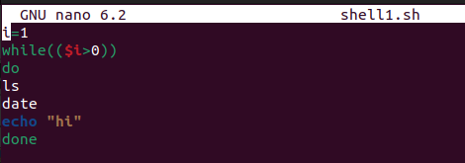

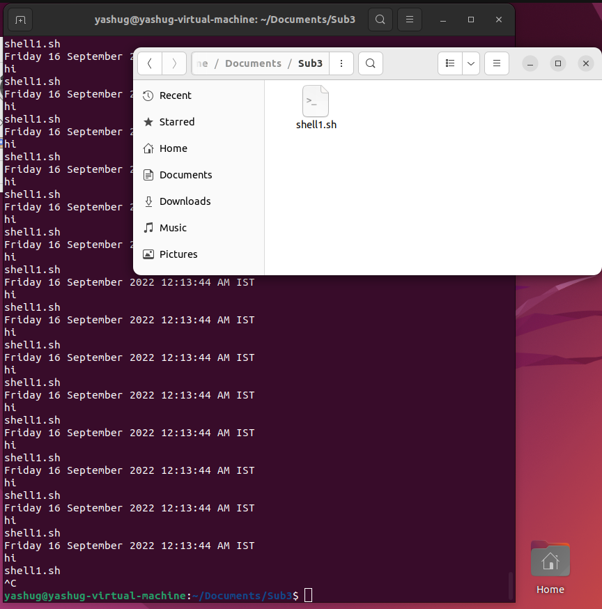

2. Write a shell script program to show the details related to shell, path and home directories of the user.

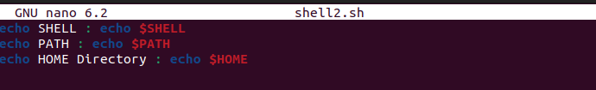

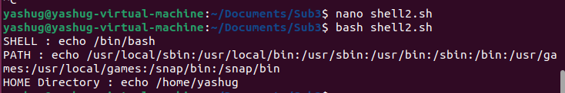

3. Write a shell script program to create two files. The name of the files will be passed by user using read function.

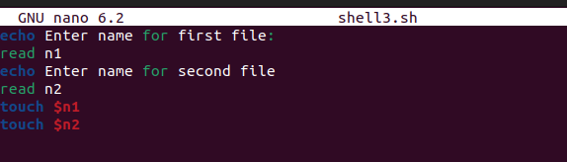

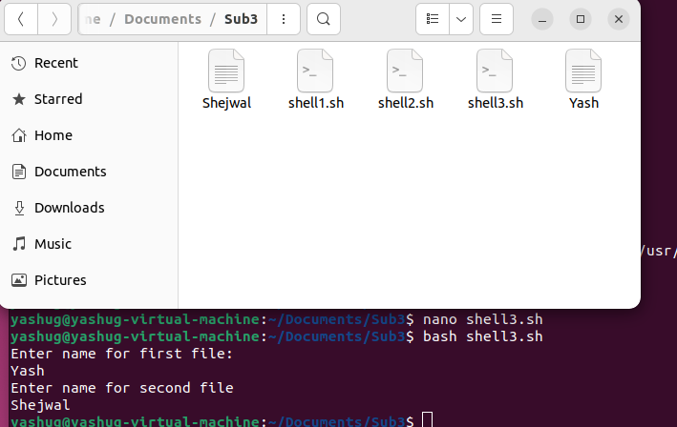

4. Write a shell script program to create two files. The name of the files will be passed by user using command line arguments.

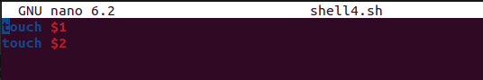

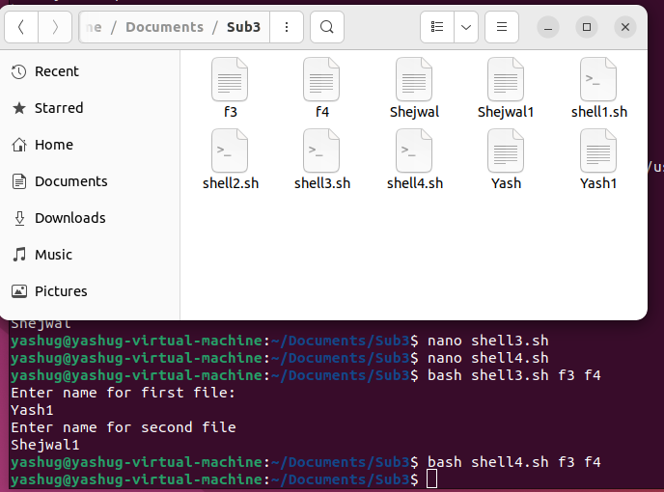

5. Write a shell script program to create two directories. The name of the files will be passed by user using read function.

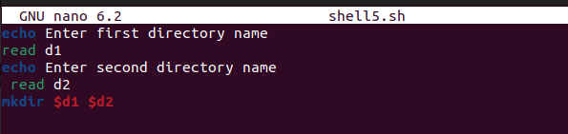

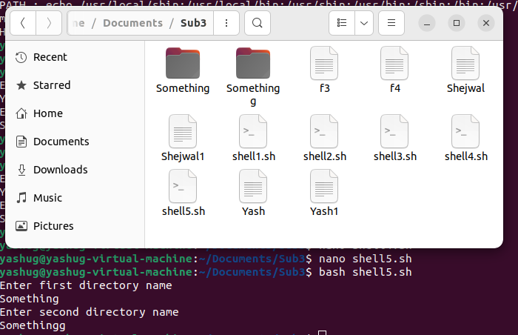

6. Write a shell script program to create two directories. The name of the files will be passed by user using command line arguments.

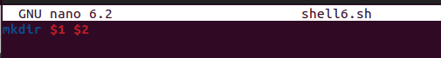

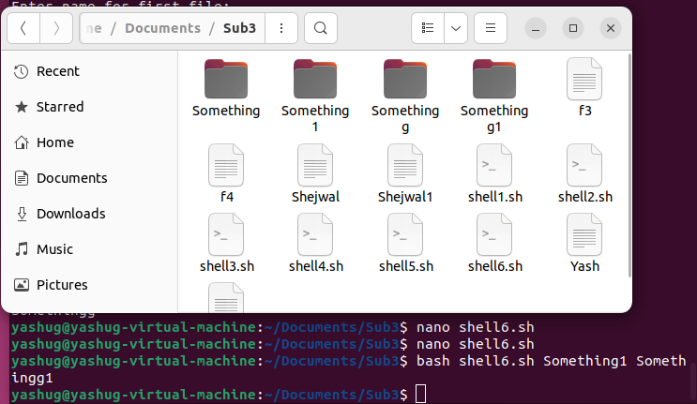

7. Write shell script to change the name of a file .Ask from user old filename and new filename.

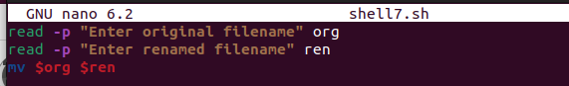

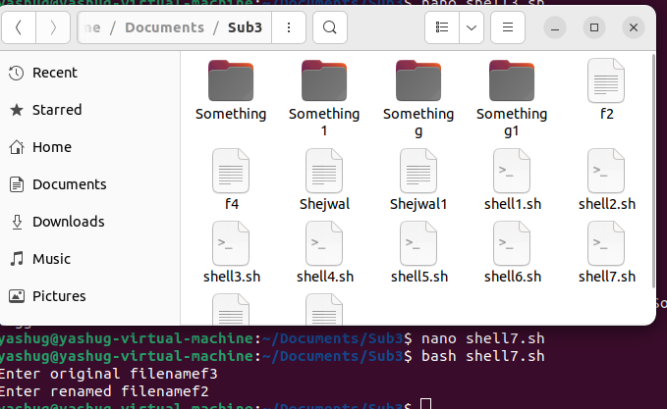

8. Write a shell script to find the largest number among three numbers.

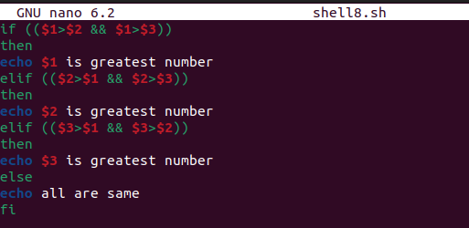



9. Write shell script to create three files f1, f2, f3 using for loop.

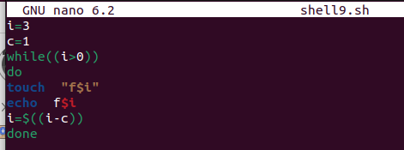

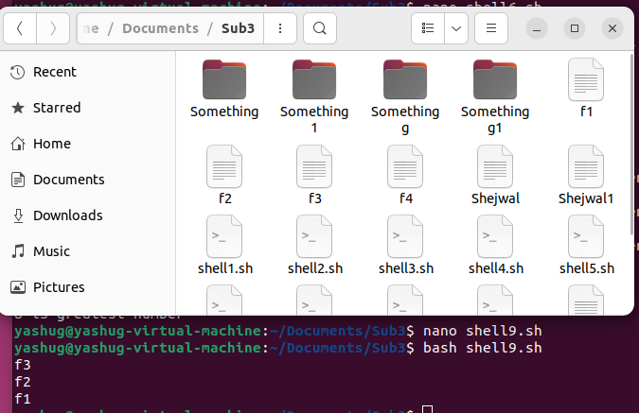

10. Write a shell script to display date and time. Assume 1 sec delay.

